**Design of Finite-Duration Impulse Response (FIR) Digital Filter**

**A few questions**

1. How are the specifications given?

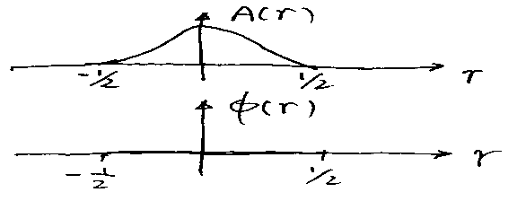

By given  and 

1. What is the form of FIR digital filter?

Difference Equation 

(What is *T* ? sampling period)

Transfer function 

1. How to select *T* ?
2. After *T* is fixed, can we define the normalized frequency *r* and

 and  ? Yes!



Can we then find the desired frequency response

 ? Yes!

1. Why must *H( r )* be a periodic function for digital filter?

*H( r ) = H ( n + r )* ? Why? What is its period?

*r* is not time



1. Can *H( r )* be expressed in Fourier Series ? Yes!

How?

See general formula :

: sampling frequency? No!  : period of 





In our case for *H*(*r*):

 

What does this mean? Every desired frequency response *H*(*r*) of digital

filter can be expressed into Fourier Series ! Further, the coefficients of

the Fourier series can be calculated using *H*(*r*)!

**Design principle**



Denote 

Consider a filter with transfer function 

What’s its frequency response ?



given specification of digital filter’s frequency response!

**Design Procedure**

1. Given *H*(*r*)

(2) Find ***H*(*r*)’s Fourier series** 

where 

(3) Designed filter’s transfer function



What’s *hd*(*nT*) ? Impulse response!

Example -10: 

Solution :

1. Given : done
2. Find ’s Fourier series



where 

*n =* 0







🡺 

(3) Digital Filter



**Practical Issues : Infinite number of terms and non-causal**

1. 

2M+1 terms

Truncation => 

Rectangular window function



Truncation ⬄ window

Effect of Truncation (windowing):

Time Domain: Multiplication ( *h* and *w* )

Frequency Domain: Convolution



(After Truncation: The desired frequency *Hr*

1.  frequency response of truncated filter )

The effect will be seen in examples!

(2) Causal Filters:



*k = n+M* 

Define 🡺 

Relationship: 

Frequency Response 

Design Examples

Hamming window: 

Example 9-11 Design a digital differentiator

Step1 : Assign 

 should be the frequency response of the analog differentiator

*H(s) = s*

=> Desired 

Step2 : Calculate *hd*(*nT*)







0



i.e., 

Step 3: Construct nc filter with hamming window (M=7)

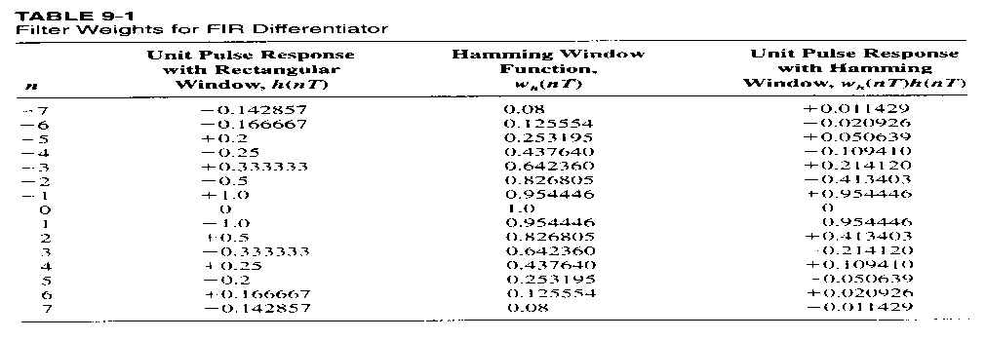 

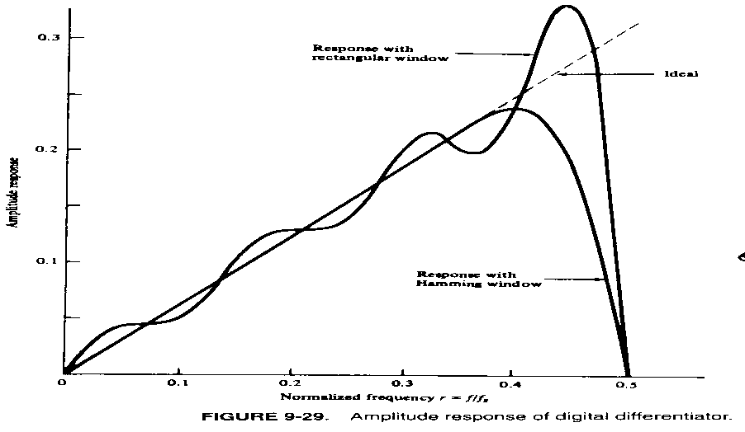

Example 9-12: Desired low-pass FIR digital filter characteristic







1. 

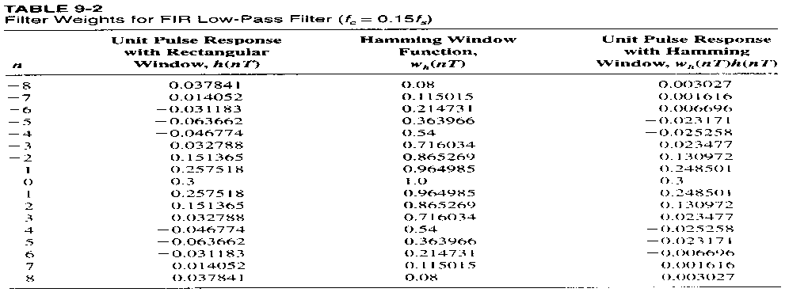

NC filter with 17 weight’s window: , 

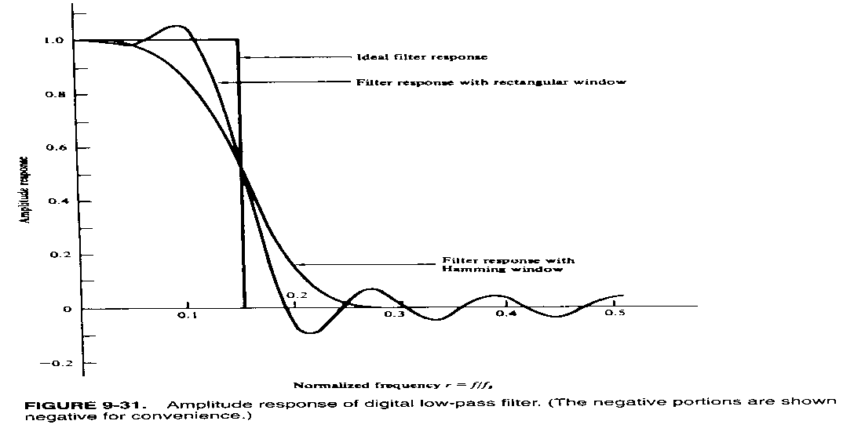

Example 9-13 (90o phase shifter)





*n* = 0 => 

1. 



=> 

Filter: 



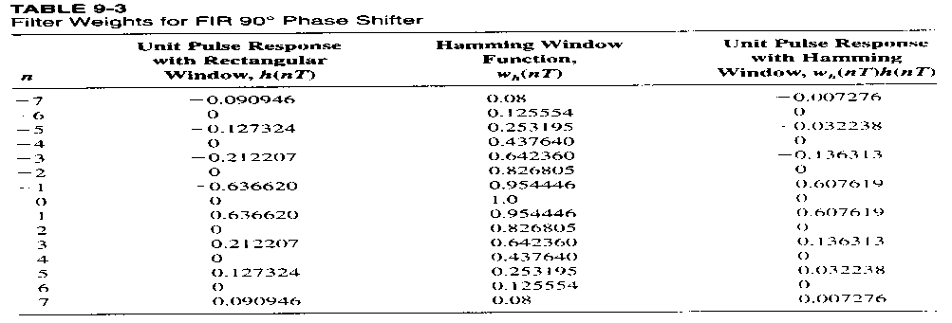

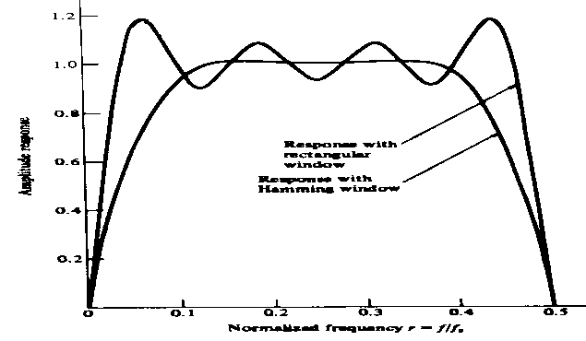

Fig. 9-32 Amplitude response of digital 90 degree phase shifter